* Simple download the installer and install.
* In the terminal we can use node commands.
* To work with node.js we need to create a server, we will use express framework for this though, but the basic theory might come handy later.
* Streams and buffers : 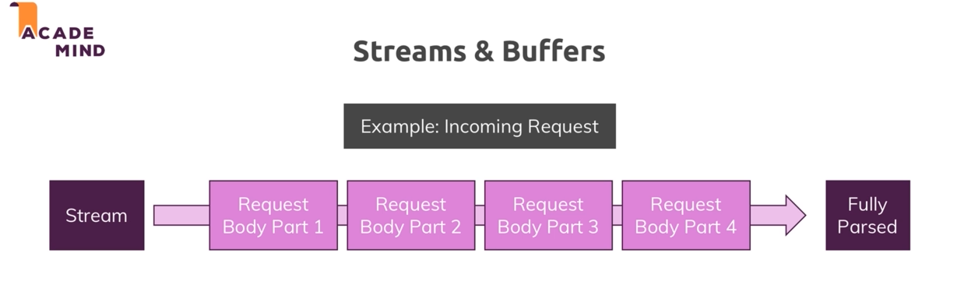

In case of small file streams doesn’t make any impact, it finishes parsing very fast and app doesn’t have to wait. But in case of big file it does make big problem, if app is to wait till everything finish it won’t be very good. This is why we work with chunks of data , we use buffer for that not stream though.

* The Node Module system is what we can use to pass function/data between files. 

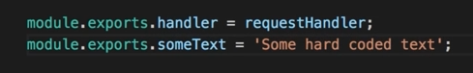

* One important syntax I need to learn is : 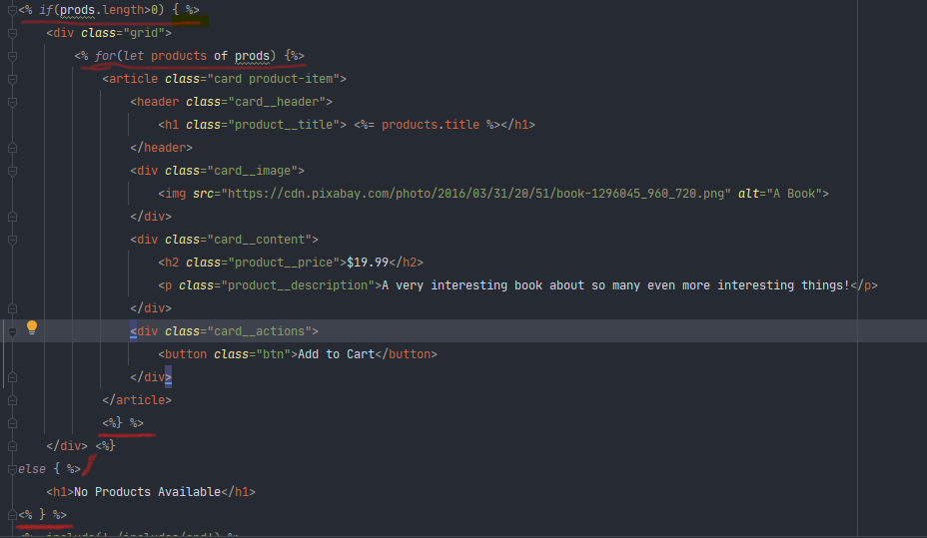
* In case of failing to shut down node server , we can go cmd and use this command

**taskkill /F /IM node.exe**

* **<%= %>**  the = inside means whatever value returned inside will show up as html element. For example
* **<% %>**  whenever we are using logic( control statement,loops etc) , which we don’t want to show inside the html, we use this. It will just run the code, not print the value inside.
* **<%- %>**